 | Newsletter  Malayalee Engineers’ Association,  Houston, Texas
Volume 5, Issue 1 |  | March 2004

The MEA2003 committee would like to thank all our members, patrons, friends and well-wishers for supporting us in all our endeavors throughout the year. This is a combined edition of the last newsletter for 2003 and the first newsletter for 2004.
NRITYA  2003 Fall Picnic and Boat Tour  METRO Presentation and GBM 2003  Annual Scholarship Grant 2003  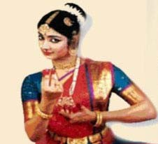 |  |  |  | 2004 Membership Drive  2004 Executive Committee  2004 Spring Picnic  2004 Cultural Night  
Spring Picnic: 03/20/04 10:00AM-3:00PM at Tom Bass Regional Park 1, Pavillion#2. 3452 Fellows Rd, Houston, TX 77047
Cultural Evening: 04/24/04 at Durga Bari Hall, 13944 Schiller Rd, Houston 77082 (near Hwy6 and Richmond, Alief)
MEA Committee members for 2004:
James Phillip (281) 265-4152 |  | Koshy Abraham (281) 492-2981 | Prafulla Pillai (281) 597-1933
Rajendran Raghavan (281) 912-7246 |  | Sibi Kuruvilla (281) 412-0127 | Suresh Jacob (281) 288-3064
All e-mails to the MEA committee to: |  | meahouston@yahoo.com | online: www.meahouston.org

NRITYA
Scholarship Fundraiser: A Grand Success

Event Overview:

Nritya, the MEA 2003 scholarship fundraiser, has turned out to be a HUGE success. For the first time in the history of MEA, we had a celebrity performing on stage. Divyaa Unni, the famous Malayalam movie star and a talented danseuse, performed live before an audience of nearly 500 who had gathered at the Stafford Civic Center at Houston. Divyaa performed a very entertaining mix of Indian classical, folk and cinematic dances, to resounding applause from the crowd. Several other talented dancers from the MEA family accompanied her.

The evening began with a brilliant performance of the Ganesha Pushpanjali, done in Bharatanatyam style by Divyaa, after which she went on to perform the Kuchippudi Tharangam, where she amazed the audience with her skill and dexterity by dancing on a plate while balancing a pot on her head. The audience also got to see Divyaa dancing to popular movie tunes like “Dola re” from “Devdas”, “Kalyanam Thaan” from the Tamil movie “Saamy”, “Chilamboli Kaate” from the Malayalam movie “CID Moosa”, “Chundathu Chethi Poo” from the Malayalam movie “Chronic bachelor” and “Thumbi Kalyanam” from the movie “Kalyana Raman”.

Nritya also boasted of several other performances by members of the MEA family. Mini Vettical and Dhinu Johny came up with an innovative piece called “Journey”, exploring the versatility of Bharatanatyam style set to western rhythm. Ashwati Kumar and Vidya Reddy performed a Kuchippudi number “Sapthaswara”. Lakshmi Sreekumar showed her mastery over the intricate footwork and rapid pirouettes of Kathak with “Kahe Chede Mohey”. She came back again to do a modern representation of the traditional Kathak by bringing out the beauty and poignance in the song “Breathless” by Shankar Mahadevan. Smrithi Franco showcased the “Thillana”, characterized by the complex footwork and statuesque poses of the dancer.

‘Urban Indian Beat’ a fusion dance group in Houston, also added to the variety of the evening by performing numbers like “Speed” (showcasing their unique style of street jazz dance), “Tapical” (a blend of Bharatnatyam and Tap Dance) and “A Girl’s Wedding” (a Bollywood performance)

The finale to the event was marked by a colorful and exciting medley group dance incorporating Hindi, Malayalam and Tamil songs performed by Divyaa Unni and group. The MC for the evening was Mrs. Kalyani Giri.

Event Outcome:

The MEA 2003 scholarship fund-raiser event was a milestone in excellence! We now proudly share with you the glad news that the total collection for the fund-raising effort has just exceeded the target of $20,000. This includes the generous contribution towards three full scholarships. We have been able to keep the expenses very close to budget.

NRITYA – Behind the Scenes…

A lot of our members and their families, who played a crucial role in all aspects of organizing NRITYA, put in much of the hard work that resulted in the success of this event. The various committees set up for the different tasks did a stupendous job and we would like to wholeheartedly thank each and every one of them. We deem it a privilege to have been able to work with such a dedicated group of men and women. From ticket-sales to providing space, time and other resources for coordinating, organizing, rehearsing and conducting the event itself, there were many challenges that we could not have overcome but for the dedicated support from many of you. We will refrain from mentioning a long list of individuals by name, but we gratefully acknowledge all the individuals who spared no effort as cheerful volunteers, who made it all happen.

Everyone in the MEA community has been exceedingly helpful and we thank you all in making Nritya a grand success. It has been a pleasure and privilege to be part of this exciting and fruitful team effort.

2003 Membership Drive: The “100” figure

Together, we have made history at MEA, by having reached a membership count of 109. We have also been able to maintain a live and active database of our members updated with current e-mail addresses. This helps us to ensure that all MEA communication reaches all our members, without missing out on anyone. At this juncture, we would like to thank everyone for being a part of the MEA family and we hope it has been a rewarding experience for you, just as it has been for us.

NRITYA: Annual MEA Fundraiser Event
A GRAND SUCCESS
(Report from the Voice of Asia)

The Indian community of Houston especially Keralites are all appreciation about the level of excellence set by the “Nritya” dance concert dished out at the Stafford Civic Center on the evening of Saturday 15 November. While the artistry of performers, lead by Divyaa Unni, the new star on the Houston cultural scene will linger in everyone’s memory, the organization that put together the event and their cause deserve to take center stage.

The Malayalee Engineers’ Association (MEA for short) deserves full credit for the excellent organization skills in pulling together this fund-raiser event, with the participation of nearly thirty performers. This organization, which came into existence in 1994, with a modest membership of about thirty engineers who hail from the south Indian state of Kerala, has today grown into over 100 strong and still growing. Their members represent practically every branch of technological activity in this city, from Oil & Gas, Engineering & Construction, Space technology, bio-technology, marine technology, information technology just to name a few.

Social interaction and professional networking were the main focus during initial years. In 2000, MEA took the bold decision of instituting a scholarship program to support academically outstanding students facing financial hardships, pursuing a four-year program leading to a degree in engineering or technology in the universities in Kerala. The motivation for the program was a keen desire to give back to the same society that had supported our own higher education.

The scholarship envisions an assistance of $ 400 per year for each scholar, for 4 years. MEA believes that this amount is adequate to cover all expenses of a student, without drawing on the meager resources of his or her family. Initially the program was started with contributions from their own members. Even before award of the first scholarship, news spread by word of mouth and a generous individual stepped in to donate a full scholarship of $ 1600 but on condition of anonymity. No doubt, MEA members were moved by this very noble gesture of charity from a non-member. The message was very clear. Society was accepting their good work from the very start, and expected them to carry it further.

A very meticulous process is in place leading to selection of the scholars and award of scholarship. The student community in Kerala is notified through media and other contacts, soliciting applications. Stringent criteria for academic merit as well as financial hardship are specified upfront.

The applications are reviewed by a dedicated group of MEA members, after which a panel of finalists is short-listed. The claims made by the short listed applicants are verified first hand through personal contacts in Kerala. Final selection is made after taking every possible care. After making out the payment for the first year, MEA insists that the scholars contact Houston at regular intervals and maintain a high level of academic performance in order to qualify for payments in subsequent years.

The effectiveness of the MEA scholarship program has been proven to some extent by the track record of one of the very first scholars, who is maintaining a high academic rank and has already been selected through campus interview, for employment by the Indian division of a US multinational IT corporation. In short MEA ensures that the scholarship helps a deserving youngster to take off in life. It is a significant social investment.

MEA awarded 2 scholarships in 2000, increasing to 4 in 2002. A total of 9 students are currently receiving assistance. In spite of the stringent qualifying criteria, MEA receives over 40 applications. Over the years MEA scholarship is getting to be noticed in Kerala and MEA expects a good demand this year. In his opening remark at the fund-raiser event, Mr. Joyce John noted that time has come for MEA to let the larger community know about their good work and also offer an opportunity to participate and offer their support.

MEA made a modest public appeal last year. But, this is the first time MEA attempted a fund-raiser of such magnitude, lining up professional performers. According to Mr. John, public response exceeded their expectations, resulting in sponsorship of two complete scholarships in addition to a gross collection of over $ 15,000. This will help MEA to create a fund for future years.

The leadership of MEA vests with a governing committee elected every year. The present committee consists of Mr. Joyce John, Mrs. Sooryakala Ellickal, Mr. Sojan Antony, Mr. Sibi Kuruvilla, Mr. Vijoy Nair and Mr. Nishanth Raj.

The fund-raiser is only the beginning of this years’ award process. MEA team is already busy reaching out to the student community and educational institutions in Kerala and has started receiving applications. Going through the applications of students coming from the weakest sections of the society and making hard decisions, is an emotionally demanding process. This opportunity to interface with the harsh realities of life motivates MEA to continue their good work with even greater zeal.

Annual General Body Meeting

The GBM for this year was held on Saturday, Oct-4, at Madras Pavilion Auditorium at Sugarland, TX.
The General Body Meeting followed lunch where the report for 2003 was presented. Nearly 30 members attended the meeting. Joyce John started the meeting by presenting the agenda followed by a brief discussion on the METRO-presentation scheduled for 3:00pm. He stressed on the fact that the committee's initiative at community outreach programs like the METRO-presentation was following the directives by several members during the previous general body meeting.
Sibi Kuruvilla presented a brief report of the year's events and planned programs. All generally lauded the successful outcome of the membership-drive, which netted paid membership of over 100 for the first time.
Sojan Antony presented the accounts, which showed the expenditure so far being controlled with a surplus in the account. MEA Cultural Evening was sustained with funds collected at the door.
Soorya Ellickal provided a historical review of the scholarship project emphasizing its growth to the current level, highlighting the need among the students back in Kerala. A healthy discussion of the project took place, with Lekha Rajan, Chith Puram and Nalinan Pillai actively providing pointers. The scholarships have been provided for well deserving students in whose lives it has made a tremendous difference. The recipients have continued to perform very well, academically. The program has received accolades in Kerala as well. It was noted that while it has been difficult to turn down some students for a lack of funds, MEA couldn’t grow the project beyond numbers it cannot handle. Four to five scholarships per year were considered to be optimal. Excess funds if any, raised in any particular year, can be pooled for years when funding could potentially be sparse. It was also emphasized that greater fiscal participation needs to be encouraged from within the MEA membership, in the Scholarship Project. The project has attracted more membership in MEA, as well.
While the scholarship project has become a mainstay of MEA undertakings every year, it was pointed out that it should not be the sole occupation. MEA needs to engage as a professional organization promoting liaisons with area universities and institutions/organizations in Kerala, by providing professional seminars and other interactions. It was noted that despite much efforts, active student membership could not be achieved so far.

A Scholarship committee was formed to review applications and process awards. Ramesh Raghavan, Rimon Vallavanatt and Balji Menon were elected to this committee.
The new MEA committee for 2004 was elected:
- Prafulla Pillai
- Rajendran
- Koshy Abraham
- Mathew
- James Philip
The proposition by Nalinan that there be an 'ex-officio' committee member from previous year to maintain continuity was carried by a great majority and Sibi Kuruvilla was nominated for this position.
An opinion was raised that all MEA members who can afford it, should take a $100 ticket for Nritya to share in the scholarship fund.
This was followed by an informative presentation on METRO Light Rail Project by Rich Krisak (Senior Director, Rail operations), Scott Grogan (Director, LRV Maintenance) and Raymond Green (Director, Maintenance of Way). The attendance was about 50 people including non MEA-members.

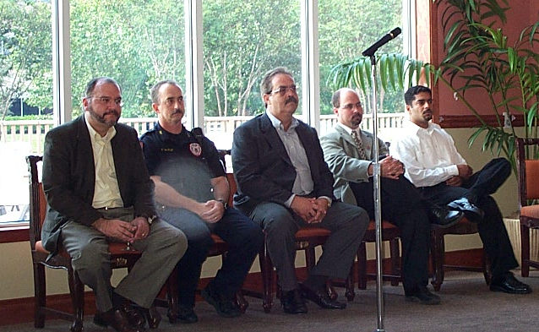

The METRO Officials at the meeting.

For more pictures, please visit our website: ww.meahouston.org

Sam Houston Boat Tour and Picnic

MEA members got a wonderful whiff of fresh sea air during the spectacular boat tour of one of the busiest ports in the world aboard the MV Sam Houston. Nearly 40 families spent almost an hour enjoying the sights and sounds of the Houston Ship Channel. This was followed by a fun-filled and “delicious” afternoon picnic at the San Jacinto Park. Lunch was served and MEA families spent time touring the Battleship Texas and the San Jacinto monument, amongst other things.

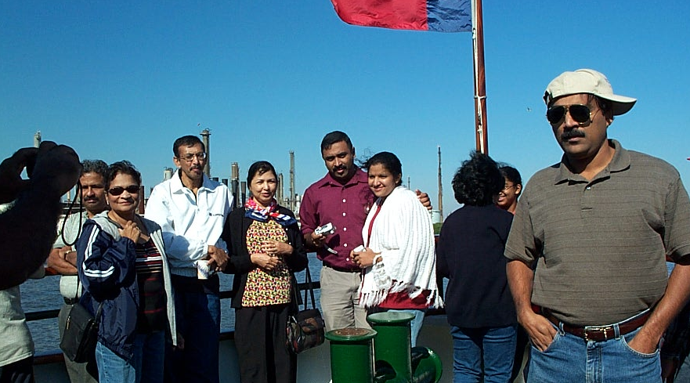
The ‘Usual Suspects’: aboard the MV Sam Houston…

MEA Scholarship Recipient Dinu Krishnan secures placement in Oracle

Dinu Krishnan, one of the first recipients of the MEA scholarship, has secured job placement with Oracle India. We consider this to be a valid testimonial of the success of our scholarship program, where we try to identify those meritorious and bright students who are in need of financial help to go forward with their college education.

Grand Sponsors for 2003

Adding to the success of Nritya as a fundraiser, are the patronage of some of MEA’s friends and family who realized the significance of MEA Scholarships and have sponsored a full award, each. These are the sponsored scholarships we received this year (2003):

- Mathai Memorial Schoralship
- Dr. N. Prabhakar Memorial Scholarship
- Sankara Pillai Memorial Scholarship

The Scholarship Project 2003: Status

We have received a phenomenal response this year to our scholarship program from the students in Kerala. We had about 200 applications this year compared to about 40 applications that we used to receive in the last couple of years. The committee has done a rigorous process of evaluation to decide on awardees for 2003.
A set of ranking aggregates formulated by the committee along with review of individual applicants was employed to select a short-list of 23 candidates. Individual contacts were established with the short-listed candidates via email, telephone, faculty at the colleges and several friends and family in kerala who helped in verifying information on the applications including need for financial assistance. The four awardees for 2003 are:
Abin Purushothaman (Ship Technology) CUSAT, Kochi.
Doni James (Electronics & Communication) CET, Tvm.
Noufal E. (Electronics) MACE, Kothamangalam.
Vijayalekshmi Kesavan (Computer Science) TKMCE, Kollam.
There were four other candidates in the short-list for 2003, for whom an MEA scholarship was not awarded, but considering their need for assistance, the committee sought help outside MEA-pool, on a personal basis. It is great to note that we have found funds to pay for two of these students fully, while the other two will be partially funded. MEA will help with administering three of these awards.
More data online: www.meahouston.org/scholarshipmain.htm

The 2003 MEA committee would like to thank each and every person who helped us through the year with our various activities. We have tried to put in our very best in carrying out the different responsibilities assigned to us. This was done keeping in mind our aim of carrying forward the goals of this organization and making it a shining example of cultural and social success in a foreign land. We have always tried to learn from all the valuable comments and suggestions that we have received after every event, and if not for the active involvement from all our members and friends, we would not have been able to go forward with our aim. We are also confident that the new committee will play an even better role in taking this organization forward, keeping in mind its vision and goals.

Membership Campaign 2004

It’s a new year and it means its time to renew your membership with MEA! Thanks to all who have sent in their checks already. Please make sure you pay the dues ($25) by the picnic-day (Mar-20). While it is great that we breached a century in membership for 2003, we need to carry the momentum forward into 2004 and make sure that we have a broad membership-base to support our initiatives. Let us make the 100-mark a consistent figure for years to come.
Please use the enclosed form or print from web at:
http://www.meahouston.org/memberapp.htm

Spring Picnic 2004

Spring is in the air and the time should be just right for a picnic! Bring your friends and family for a fun-filled day at the Tom Bass Regional Park 1, at Hwy288 and Bwy8. Directions are enclosed. Proceed to Pavillion #2 in the park, beside a gazebo and children’s playground.
We have a General Body Meeting scheduled for the day as well. Lunch will be served at noon. The event is free for all MEA members, but guests will be charged $5.00 to offset costs. If you can organize a fun/sport activity for the day, please contact the committee ASAP.

MEA Cultural Evening 2004

Mark your calendars for the evening of Saturday, April 24th. We’ll have a Social Hour from 4:00pm to 5:00pm, the Cultural Program from 5:00pm to 8:00pm, followed by Dinner at 8:00pm. Please arrive on time, with your family and friends.
We need a head-count for ordering food, so kindly RSVP with any of the committee members, at the earliest.

The cover charges are:
$12 per adult, $5 per child (5-12 yrs) for members & family.
$15 per adult, $5 per child (5-12 yrs) for guests.
Here’s a chance to showcase your talents! Please contact Uma (281-913-7246, arunvarun@aol.com) with details of your item.
We need volunteers for making snacks, hall-arrangement, hospitality and food service. Please contact a committee member (or email: meahouston@yahoo.com) if you can join us in making MEA-nite ‘04 a grand success.

Venue: Houston Durga Bari Society Auditorium,
13944 Schiller Rd, Houston 77082.
(near Hwy6 and Westpark, Alief. www.durgabari.org)
(If there is heavy traffic on HWY 6, go forward to the next signal and make u-turn to avoid waiting for a LEFT turn)
We’ll have more details on MEA-nite ’04 at our website, soon.

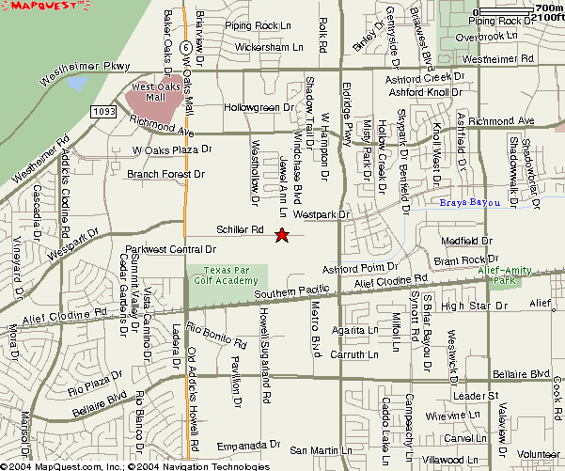

MEA Houston: 2004 Membership Form
Name: ___________________________________________________ email: ______________________

Home Address: _________________________________________________________________________

_________________________________________________________________________

Tel# (home): ______________________________ (work / cell): _______________________________

Employer: _____________________________________________________________________________

Hometown in Kerala: ____________________________________________________________________

Do you wish to block your contact information from being published and distributed? (check) Yes__ No__

Please mail with check ($25 payable to MEA Houston) to: Rajendran Raghavan, 4207 Brookshadow Dr., Kingwood, TX 77345.

* Curios * Art * Chandeliers * Gift Items * Bedrooms * Living rooms * Formal Dining * Dinettes * Home Décor * Office * Casuals *
Furnish and decorate your entire home! UNIQUE FURNITURE
Call Tom at (713) 899-5070 or (281) 403-2973 Brand-name furniture at amazingly low prices
Free delivery in Houston. Mention MEA for a special discount!
JOSEPH T. JOSEPH, P.C.  C E R T I F I E D P U B L I C A C C O U N T A N T  Joseph T. Joseph  8303 SW. Freeway Tel: (713)271-3300  Suite 335 Fax: (713)270-7048  Houston, TX 77074 email: josecpa@aol.com | ABRAHAM THOMAS  281-561-8458  ALAMO TRAVEL  Domestic & International  “HERE WE CARE”  435 FM 1092, Suite U-1 Office: (281) 261-3000  Stafford, TX 77477 Fax: (281) 261-8232  Abrahamt2001@hotmail.com
 |  | India Jewelers  Your Diamond Source  Olympic Center, 6638 S.W. Freeway @ Hillcroft  Houston, TX 77074
 | Tel: (713) 789-7575 Fax: (713) 789-4851

If undelivered, please return to:

Rajendran Raghavan
For Malayalee Engineers’ Association (MEA), Houston
4207 Brookshadow Dr.
Kingwood, TX 77345

