MEA would like to thank all its members, patrons, friends and well wishers for supporting MEA in all its endeavors throughout the years. We humbly request all members to remain actively involved with MEA and make 2011 another memorable year for the organization.
Events for the Year 2011:  - Spring Picnic & GBM  - 2011 Scholarship awards  - Musical Night – Scholarship Fundraiser  - MEA Cultural Nite and Onam Celebrations  - Christmas Dinner |  |  |  | Newsletter Contents:  - Celebration of Thankam’s Life  - Spring Picnic & GBM  - MEA Musical Night and Fundraiser  - 2010 Scholarship Award updates  - 2011 Membership drive
 | MEA BOD for 2011
President: Joseph Mathew | Secretary: Basil Theckumpurath |  | Treasurer: Srijith Puthen
Communications: Sanjay Poduval |  |  | Events: Regina Joseph
meahouston@yahoo.com |  |  | www.meahouston.org

Celebration of Thankam’s Life

The sad demise of our beloved member, “Thankam Aunty”, shook our whole organization. Cheerful and smiling Thankam Aunty, who greeted all of us during the Spring Picnic, is no more among us.

In celebration of the brilliant Engineer “Prafulla”, MEA and IEEE members, KBR Employees and Managers, friends, relatives, and professionals from far and near congregated on May 21st and bid farewell to the departing soul.

The event was filled with heart throbbing moments, especially when speakers stood up to remember their associations with this wonderful lady and paid their tribute.

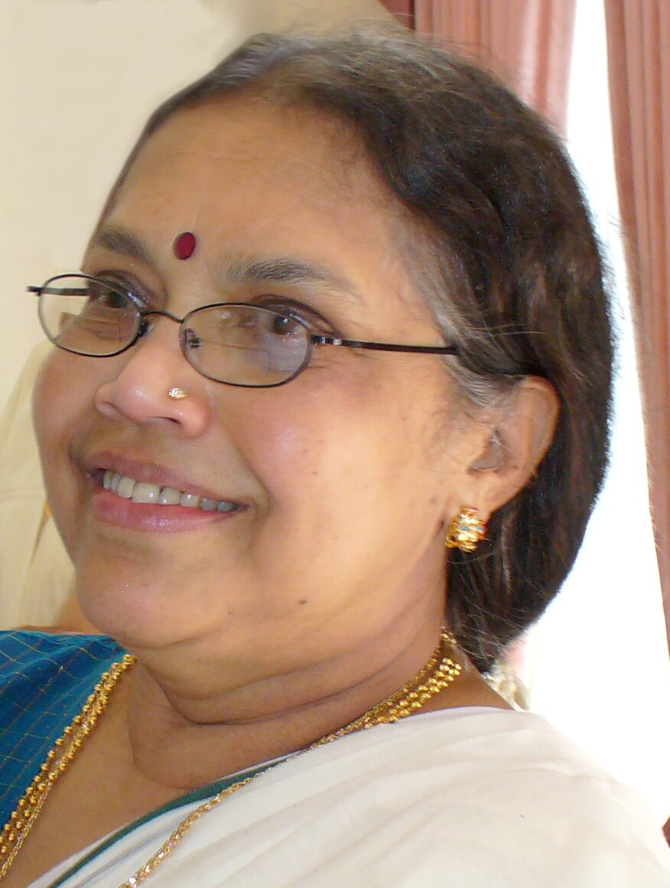

As one of the speakers summarized towards the end “she was persistent, humble & graceful”.

Thankam Aunty’s contributions to MEA and the scholarship program are beyond words.

Let us all take an oath to follow her footsteps in MEA and professional activities.

May Her soul Rest in Peace

The 2011-BOD would like to express our gratitude to all friends and family for their dedicated efforts to make the Spring picnic at the Lost Creek Park, Sugarland another memorable event in making 2011 another successful year for MEA.

The picnic was well attended and proved to be great fun for the entire family. Members’ enjoyed several games including cricket and tug of war. We had “kappa & meen” for lunch. We had General Body Meetings where amendments to by-laws were made. The picnic was concluded with the official kick-off of the MEA Musical Nite

Annual scholarships for ten new engineering students were awarded in March 2011 in addition to the existing recipients. It is agreed in the GBM to increase the number of scholarships from ten to twelve for the year 2012. MEA expresses its gratitude to all the members, donors and partner organizations whose contributions have made the scholarship program a big success.

The annual scholarship fund raiser event, Raga Sandhya Musical Nite is scheduled for June 24, 2011. The Musical Nite would be led by Sri. G Venugopal, the leading playback singer in the South Indian film industry and famous Ghazal singer Gayathri. The venue for the event will be old Stafford Civic Center. BOD encourages all MEA members to actively involve in the selling of tickets for the event to the Houston Malayalee community.

The annual MEA Cultural Nite for the year 2011 will be organized in September along with the Onam Celebrations.

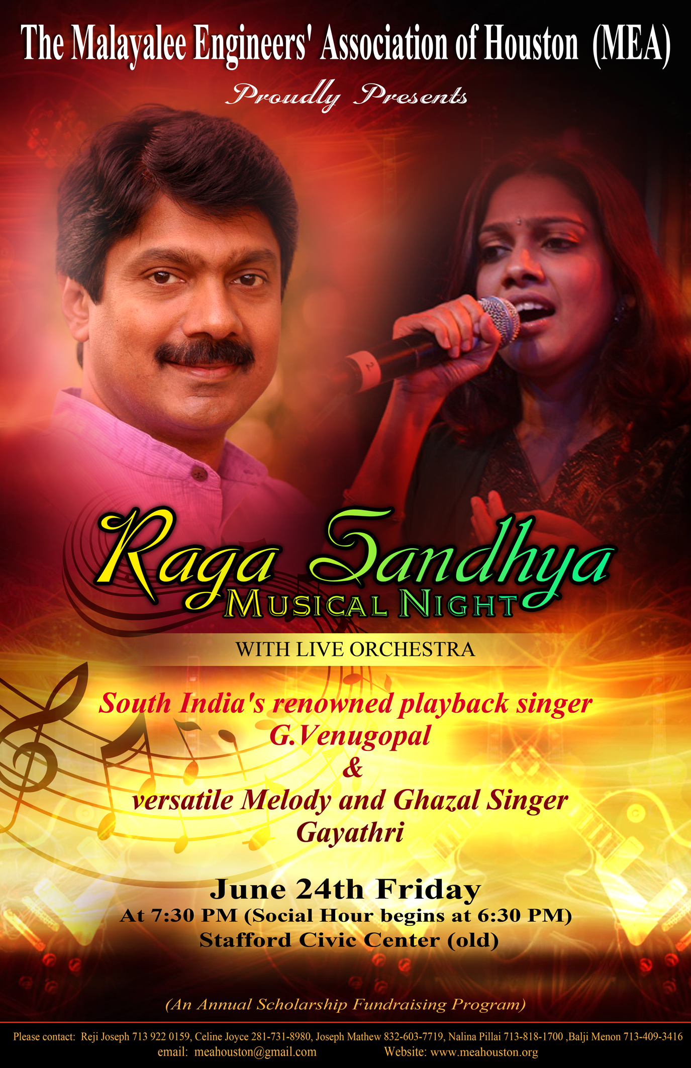

Eleven (11) engineering students in Kerala have been selected to receive the MEA scholarship. Their details are listed below. The students have been selected after a detailed review of their applications using the MEA scholarship award guidelines and a thorough background information check.
List of Scholarship Recipients – 2010
Sl. No | Student | College
1 | Gilson Varghese | School of Engg, CUSAT
2 | Abhijith M V | Model Engg College, CUSAT
3 | Madhusoodanan S | NSS College of Engg, Palakkad
4 | Prajwal T S | TKM College of Engg, Kollam
5 | Sreeraj Sreedharan | TKM College of Engg, Kollam
6 | Akhil V P | Govt. Engg College, Barton Hill, TVM
7 | Shibin T V | NIT, Calicut
8 | Snubin T | TKM College of Engg, Kollam
9 | Jishnudev T M | College of Engg, TVM
10 | Emmanuel Bristow Kubalio | College of Engg, TVM
11* | Arathi Nair | SCT College of Engg, TVM
*Prof. Krishnankutty Memorial Scholoarship

MEA 2011 BOD

The MEA committee for 2011 took over the responsibilities from the office bearers of 2010 MEA committee in January. The board of directors of MEA 2011 constitutes of:

- Srijit Puthen (Treasurer)
- Joseph Mathew (president)
- Regina Joseph (Event Chair)
- Basil Theckumpurath (Secretary)
- Sanjay Poduval (Communications)

“Cuppa Over Cricket" ( MEA Spring outdoor Bash)
The MEA Spring family picnic and General Body Meeting (GBM) was held at Lost Creek park in Sugarland on Saturday, March 26th. Various outdoor games and sports activities were organized in the picnic. The games included Cricket and Tug of War, Spoon race, Musical chair. More than 100 MEA Family members and guests attended. The tickets for the Musical Nite were distributed to the organizing committee.
It was unanimously agreed in the GBM to name one of the MEA Annual scholarships after late Prof. Krishnankutty.



MEA Scholarship Fundraiser - 2011

The annual scholarship fund raiser event, Raga Sandhya Musical Nite is scheduled for June 24, 2011. The Musical Nite would be led by Sri. G Venugopal, the leading playback singer in the South Indian film industry and famous Ghazal singer Gayathri. The venue for the event will be old Stafford Civic Center. BOD encourages all MEA members to actively involve in the selling of tickets for the event to the Houston Malayalee community.

MEA Cultural Nite - 2011

The annual MEA Cultural nite for the year 2011 will be organized in September along with the ONAM celebrations
Loss of a Friend of All of us
We, the Malayalee Engineers all over the world, especially many of us in Houston, Texas and other parts of USA are shocked and saddened by the demise. Prof. Krishnankutty. He was one of the finest human being some of us have ever met. He was more than a teacher, but a man with great vision and compassion to help his students and engineering community in any way he could. His words always radiated true sincerity and kindness. His willingness to meet our members at home, hotel or accompany us to temples, no matter whether he was sick or healthy was incredible.
The meetings he arranged for the recipients of MEA scholarship to meet our members when they visited Trivandrum are memorable and were extremely useful to the students and us. Our members’ interaction with him helped them to better understand compassion and dedication to one’s purpose in life.

Advertising in MEA Website & Newsletter

The MEA website and newsletter offer a tremendous opportunity for local businesses based in Houston to advertise and reach out to a large community.

The advertising fee is fixed at 50 USD per year providing advertisement space on the MEA website, the quarterly newsletter and also at the various annual events and picnics hosted by MEA. In addition to providing advertisement benefits to the businesses, this will also provide valuable contributions to the scholarship fund.

If you are interested in advertising options through MEA, please email meahouston@yahoo.com for more information.

Corporate Donation Matching

Donations to MEA are tax exempt under 501 (c) (3) and many major corporations will match employee donations to MEA. Members are requested to check with their employers if such a scheme is available within the company which can supplement their contributions to MEA.

For 2010, such corporate matching of donations contributed approximately 3000 USD in 2010 to the scholarship funds, in addition to their contributions in the previous year. These contributions match 6 scholarship commitments from our members

Corporate Sponsors

Microsoft Corporation 1 Scholarship
General Electric 2 Scholarships
SBM 1 + Scholarships
Chevron Part Scholarship

MEA 2011 Membership Drive

The success of MEA depends on its members. Members are encouraged to renew their memberships for the year 2011. The annual membership fee has been revised to 35 USD. Payments can be made with check or cash to the treasurer. MEA also provides the opportunity to make membership payments online at www.meahouston.org using Paypal.

Please spread the word and encourage your friends to join MEA and help the organization grow.

Call for Articles

Writers in MEA family: Please send in articles (technical, non-technical, humorous notes), stories, notices about important events, announcements etc. We will publish them in the next issue. The newsletter presents a great opportunity to the MEA member families and children to showcase their literary talents. It also helps us in making the newsletter more interesting and exciting.

Please email your articles to meahouston@yahoo.com.

