 | Newsletter  Malayalee Engineers’ Association,  Houston, Texas
Volume 9, Issue 1 |  | June 2008

We look forward to a year of active participation of all our members, patrons and well wishers in all our ventures this year.

Upcoming cultural night announcement
Scholarship awards 2007
Spring 2008 Picnic highlights
Current boom in the Marine industry
Oil and Gas Industry-Some facts

MEA Committee 2008:
Rajendran Raghavan-President  (281) 913 7246 | Sreekumar K Thampi-Treasurer  (832) 621 6292 | Balji Menon-Secretary  (713) 409 3416
Suresh Narayanan-Member  (713) 826 6114 | John Mathew -Member  (281) 685 5052 | Sonia Samuel-Member  (713) 492 8994
Rajesh K Narayanan-Scholarship Co-ordinator  (832) 488 7790 | Email:meahouston@gmail.com | Website:www.meahouston.org

MEA Scholarship awards 2007

A record number of eight MEA scholarships were awarded for the 2007-2008 academic year. After an exhaustive voting process, the scholarship committee declared the following applicants as the winners.

Santhosh .R-Model Engineering College,Thrikkakara
Computer Science
Anoop .E.M-College of Engineering, Trivandrum
Electronics&Communication
Harish Babu M-College of Engineering, Trivandrum
Architecture
Bibin Mohanan-College of Engineering, Trivandrum
Electronics&Communication
Dennis Babu-T.K.M Engineering College, Quilon
Electronics&Communication
Kannan D-Mar Athanasius college of Engineering, Kothamangalam
Rajesh PV-Govt.Engineering college, Thrissur
Electronics&Communication
Sreeni .P-Govt.Engineering college, Thrissur
Electronics&Communication

From this year on, the scholarship amount has been raised to $ 2000 ($ 500 per year) and the first year installments have already been mailed to all the recipients. The scholarship committee decided to award a partial scholarship ($ 250) to one of the winners, Anoop E.M., since he had reported receiving scholarship from other sources. Scholarship checks ($ 400 per year) have also been mailed to 10 of the prior year winners.

Congratulations to all the winners and thanks to the MEA scholarship committee for a job well done!

We have already kicked off the scholarship drive for 2008-2009. We are happy to report that we have received commitments for two full scholarships-one sponsored by Drs. Priya & RK Nair of Dallas and one from the Nidhi Memorial Fund.

.

MEA Annual Cultural night is here!

When: September 6th, 5 pm – 8 pm
Where: The Woodlands High school
6101 Research Forest Drive
The Woodlands 77381

MEA will hold its Annual cultural Night this year on September the 6th from 5 pm to 8 pm at The Woodlands High School. As always this provides a great opportunity for all MEA family members to display their talent and share an enjoyable evening with other members. So let out the artist in you and express yourself through a song, dance, skit, mono-act, play, stand-up comedy…and we leave the rest to your creativity.

Come join us with your loved ones for an evening of sheer fun and entertainment. A great place to share the rich culture of Gods Own Country.

For event sign up please contact any of our cultural committee members not later than August 1st, 2008.

Anoop- anoopanju@earthlink.net
(281) 286 3929
Preetha- Preetha.Thampi@cityofhouston.net
(281) 992 3181
Kanchana-harmeni@earthlink.net
(936) 321 6947
Uma- arunvarun@aol.com
(281) 913 7246

We hope to see you there!

We strongly encourage our valued members to contribute to this worthy cause as in the previous years. Your checks can be made out to the Malayalee Engineers Association and sent to the following address.

Sreekumar Thampi
Treasurer, MEA
16118 Arborlea Drive
Friendswood, TX-77546

Thanks for your support.

******************************************

Spring 2008 Picnic Highlights

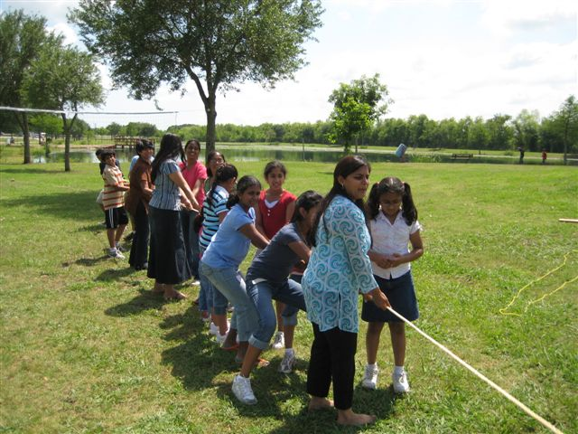

Tug of war….a scene from the spring 2008 picnic.

The first picnic of the year was held on Apr. 26, ’08 at the Kitty Hollow Park in Sugarland, TX. Bad weather in parts of the metro area contributed to a lower than expected turn out, but our crowd had a fun time with games (organized by Suresh Narayan), bingo (Uday Salian), children’s events and of course tug-of-war. Lunch (arranged by Kumari Radhakrishnan) was from an unprecedented submarine sandwich and fruits menu !

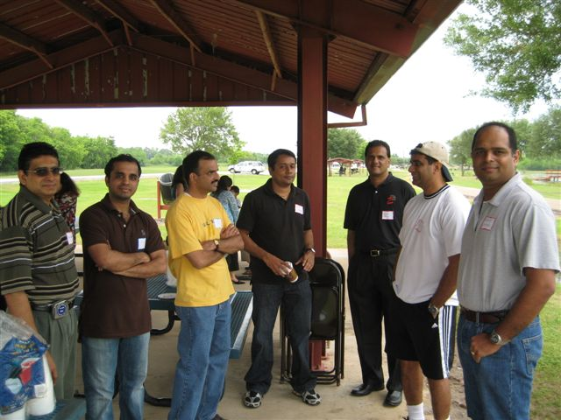
Engineers in action….

A short GB meeting was held to announce scholarship awards, membership drive and plans for the rest of the year. Nalinan Pillai and Chith Puram pointed out the dire need for funding to maintain the UT Austin Malayalam curriculum.

Our designated photographer Anoop Nair managed to get a lot of photos taken, a few are attached here. The rest may be viewed on our website.

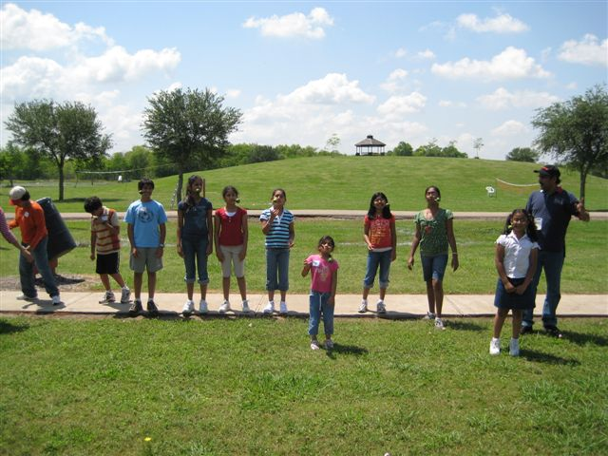
More games….

Thank you for making this a memorable event.

Membership Campaign 2008

We would like to remind you to please make sure you pay your membership dues ($30) at the earliest. Thanks to all who have sent in their checks already. Let us make sure that we have a broad membership-base to support our initiatives.

Please mail in your checks to

Sreekumar Thampi
16118 Arborlea Dr,
Friendswood, TX 77546.

Current Boom in the marine industry

This is a period of tremendous marine design and construction worldwide, particularly in the large Asian economies as they experience rapid growth, with the demand for energy, raw materials and finished goods increasing correspondingly. As a result, the marine industry as a whole is experiencing a sustained boom in the construction of ships and offshore structures.
2007 was reported as “a truly remarkable year,” with record order book at shipyards and owners and operators reporting record fleet size, acknowledging that all other supporting industry has benefited from the quite extraordinary “bull run” of the last few years. Continued high levels of activity in the offshore sector, on both the exploration and production sides also contributed to a significant portion of the industry’s success in 2007.
It is worthwhile noting that the global nature of the industry and the strength of its reputation have meant that the self-regulatory mechanism of the marine industry is very effective with no compromises to maritime safety. Several new initiatives that enhance maritime safety and protect

the natural environment have also been established.
While it is difficult to assess the rationality of the continued pace of ordering in both the ship and offshore sectors, it is equally difficult to predict if or when the inevitable slowdown will occur. But for now, experienced marine personnel particularly with engineering background are in high demand in shipyards, ship design firms, equipment manufacturers, as well as with ship owners and operators.
Oil and gasoline-some facts

- The total amount of proven oil reserves held by all investor owned oil companies (IOCs) is just 6%
- Almost 80% is exclusively controlled by foreign national oil companies (NOCs)
- When you pay 1 dollar at the gasoline pump, 58% is the crude oil price, 17% is for refining, 10% for the retail and 15% taxes
- The oil and gas industry profit margin is about 8% compared to the 22% profit margin for beverage and tobacco products
- Who owns “big Oil “companies? You! ( Look at the investment mix:29.5% Mutual funds etc, 27% pension funds, 23% individual investors, 14% IRAs, 5% others and just 1.5% is corporate executives)
Gasoline Saving Tips
- Do not drive.
- If you must drive have your car tuned regularly. An engine tune-up can improve car fuel economy by an average of 1 mile per gallon.
- Keep your tires properly inflated. Under-inflated tires can decrease fuel economy by up to 1 mile per gallon.

Gasoline saving tips Contd…
- Slow down. The faster you drive the more gasoline your car uses. Driving at 65 miles per hour rather than 55 miles per hour reduces fuel economy by about 2 miles per gallon.
- Avoid jackrabbit starts. Abrupt starts require about twice as much gasoline as gradual starts.
- Pace your driving. Unnecessary speedups, slowdowns and stops can decrease fuel economy by up to 2 miles per gallon.
- Use your air conditioner sparingly. The use of air conditioning can reduce fuel economy by as much as 2 miles per gallon.
- Avoid lengthy engine idling. Turn your engine off when you are delayed for more than a couple of minutes.
- Plan your trips carefully. Combine short trips into one to do all your errands. Avoid traveling during rush hours if possible, to reduce fuel-consumption patterns such as starting and stopping and numerous idling periods. Consider joining a car pool.
Wisdom from above
A man is flying in a hot air balloon and realizes he is lost. He reduces height and spots a man down below. He lowers the balloon further and shouts, "Excuse me, can you tell me where I am?"
The man below says, "Yes, you're in a hot air balloon, hovering 30 feet above this field."
"You must be an engineer," says the balloonist.
"I am," replies the man. "How did you know?"
"Well," says the balloonist, "everything you have told me is technically correct, but it's of no use to anyone."

The man below says, "You must be in management."
"I am," replies the balloonist, "but how did you know?"
"Well," says the man, "you don't know where you are, or where you're going, but you expect me to be able to help. You're in the same position you were before we met, but now it's my fault."
************************************


Have a Great Summer! Stay Cool!!

If undelivered, please return to:

Rajendran Raghavan
For Malayalee Engineers’ Association (MEA), Houston
4207 Brookshadow Dr.
Kingwood, TX 77345

